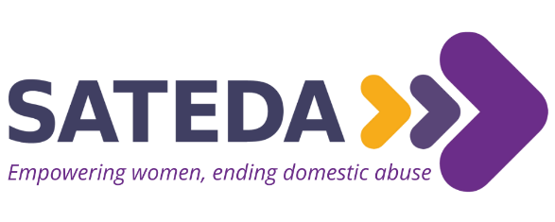

Equality Monitoring Form

SATEDA strives to meet the aims and commitments set out in its Equality and Diversity policy. This includes not discriminating under the Equality Act 2010, and building an accurate picture of the make-up of the workforce in encouraging equality and diversity.
We need your help and co-operation to do this, and we’d be grateful if you could fill out the following voluntary and anonymous form so we can monitor equalities information and ensure that we are treating all candidates fairly and appropriately.
This information will be treated confidentially and will not be used in any part of the selection process. It will only be used for monitoring purposes.
If you have any questions about the form, please contact admin@sateda.org.

Job Post: ________________________________________________

Gender
☐ Female ☐ Non-Binary
☐ Male ☐ Prefer not to say

If your gender isn’t recognised above, please describe here _________________________________________

Do you recognise your gender as the same gender you were assigned at birth?
☐ Yes ☐ No

Age
☐ 0-18 ☐ 30-40 ☐ 60-70
☐ 18-25 ☐ 40-50 ☐ 70+
☐ 26-30 ☐ 50-60

Nationality
☐ British ☐ Other EU country
☐ Irish ☐ Other non-EU country

National Identity
How would you describe your national identity? _____________________________________________

Do you recognise your nationality and national identity to be the same? _______________________________________________________

Ethnicity
White Asian/ Asian British
☐ British/English/Welsh/ Northern Irish/ ☐ Indian
Scottish ☐ Pakistani
☐ Irish ☐ Bangladeshi
☐ Gypsy or Irish Traveller ☐ Chinese
☐ Other White Background ☐ Any other Asian Background

Black Mixed/Multiple ethnic groups
☐ African ☐ White and Black Caribbean
☐ Caribbean ☐ White and Black African
☐ Other Black, African or Caribbean ☐ White and Asian
background ☐ Any other Mixed/Multiple ethnic
background

If your ethnicity isn’t recognised above, please describe it here ______________________________________

Sexual Orientation
☐ Heterosexual ☐ Gay ☐ Lesbian
☐ Bisexual ☐ Pansexual ☐ Asexual

If your sexual orientation isn’t recognised above, please describe it here ___________________________

Religion
☐ No religion ☐ Hindu ☐ Buddhist
☐ Agnostic ☐ Jewish ☐ Sikh
☐ Christian ☐ Muslim

If your religion/faith isn’t recognised above, please describe it here _________________________________

Disability
Disability is described by the Equality Act 2010 as a physical or mental impairment that has a substantial long-term adverse effect on an individual's ability to carry out normal day to day activities.
Applications from disabled people are welcome. We will ensure that appropriate support is provided where required, both in the recruitment and selection process, and during employment.

Do you consider yourself to have a disability?
☐ Yes ☐ No ☐ Prefer not to say

Thank you for completing this form.

Please return in a sealed envelope with your application form or email it separately from your application form to recruitment@sateda.org stating your name and post applying for.

The above information will not be shared with the selection panel prior to interview.

This information will be retained, confidentially, and used for monitoring purposes.

