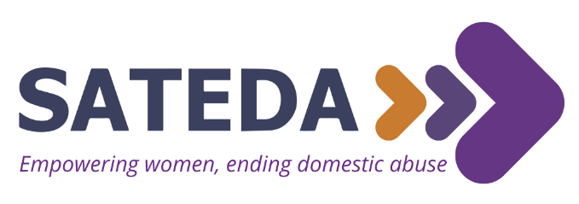

Parental Consent Form for Young Volunteers
Welcome, SATEDA volunteer! Thank you so much for your interest in supporting the launch of our new project. We require parental/legal guardian consent in order to accept any application from a volunteer who is under the age of 16 (at the time of application), so please read everything carefully with your parent/legal guardian, and each fill in your details below.
SATEDA is a specialist domestic abuse charity campaigning for systemic change around gender-based violence, while empowering and enabling women to end the cycle of domestic abuse, heal and rebuild their lives. We do this through specialist support, education and advocacy, which includes support and prevention work for children and young people. For information about SATEDA please visit www.sateda.org
In 2022 we will be launching social media accounts (Instagram and TikTok) which are aimed at young people, called ‘Does It Feel Wrong?’. We want this project to be led by young people like you – as you know your generation best! – who will have ongoing support, guidance and supervision from SATEDA’s Campaigns and Marketing Assistant, Juliette Lyons. Here is more information about this particular role for you and your parent/legal guardian. If you have any questions, now or in the future, please don’t hesitate to contact juliette.lyons@sateda.org
Aims of the Does It Feel Wrong? project volunteer role:
- Creating engaging resources to equip and educate young people about healthy relationships and the context in which unhealthy relationships occur
- Break the stigma of abusive relationships among young people – it doesn’t just happen to adults
- Empower girls and non-binary people to break free of abusive relationships
- Make girls and non-binary people aware that SATEDA exists to support them too
- Engaging boys into the conversation
Tasks we are looking for Does It Feel Wrong? project volunteers to participate in:
- Drafting and circulating a survey for young people in local schools to understand gaps in their understanding of healthy and unhealthy relationships, to guide ‘Does It Feel Wrong’ content
- Researching themes (https://yourbestfriend.org.uk/ – scroll down to the bottom there are some great themes listed on this website)
- Brainstorming and creating content aimed at young people for Instagram and TikTok (writing engaging, informative and simple copy, designing on Canva, making videos, etc)
- Highlighting the work of teenage artists exploring abusive relationships and female empowerment
- Working with teenage artists to design billboards for our youth awareness campaign (summer/autumn 2022) in Swale which will be aimed at 13-18 year olds
As this project will be led by young people, the above tasks will vary depending on your ideas and those of the other young volunteers working on this project.

Your Details (to be completed by applicant, so we can match this form to your volunteer application/record)
First Name | Click or tap here to enter text.
Last Name | Click or tap here to enter text.
Date of Birth | Click or tap here to enter text.
Email address | Click or tap here to enter text.
Phone Number | Click or tap here to enter text.
Are you eligible to volunteer in the UK? | Click or tap here to enter text.

We can support volunteering for young people aged 14+, but you can only register on our site if you are aged 16+. So, if you are aged 16+ please register on our volunteer database here.

Your Parent/Legal Guardian’s Details (to be completed by a parent/legal guardian)
First Name | Click or tap here to enter text.
Last Name | Click or tap here to enter text.
Relationship to applicant | Click or tap here to enter text.
Email address | Click or tap here to enter text.
Phone Number | Click or tap here to enter text.

 | YES | NO
I am aware of the nature of SATEDA’s work and this means there may be times when abuse is discussed around the applicant | ☐ | ☐
I understand that in order to fulfil this volunteer role, the applicant’s details will be safely and securely stored on a database | ☐ | ☐
I consent to the applicant taking part in this specific volunteering role at SATEDA | ☐ | ☐
I give permission for SATEDA to take photographs/videos of the applicant and share on social media | ☐ | ☐
I give permission for SATEDA to take photographs/videos of the applicant for Does It Feel Wrong? project promotional material | ☐ | ☐
As the volunteering will largely be taking place from home, please confirm that you agree to monitor the wellbeing of the applicant whilst they undertake this role | ☐ | ☐

Signature of Parent or Legal Guardian  (Electronic signature – no need to print & scan) | Click or tap here to enter text.
Print Name | Click or tap here to enter text.
Date | Click or tap here to enter text.

Thank you for taking the time to read through and complete this form. Please email it to juliette.lyons@sateda.org so we can get you started!

